Cybersecurity Analyst Internship
Task Report

[samfelix15@gmail.com]
Task No: [11 - Network Scanning]

Copyright © 2024 EncryptEdge Labs. All rights reserved
Credit: Offensive Security

Table of Contents
1.0 EncryptEdge Labs Internship Task Report 2
1.1 Introduction 3
1.2 Objective 3
1.3 Requirements 4
2.0 High-Level Summary 7
2.1 Recommendations 7
2.2 Risk exposure over time 8
3.0 Report - Methodologies 8
3.1 Information Gathering 10
4.0 Additionals Item 12
1.0 EncryptEdge Labs Internship Task Report
1.1 Introduction
In today's digital landscape, cybersecurity is a top priority for organizations of all sizes. As technology advances, cyber threats are becoming increasingly sophisticated, making it essential for organizations to implement robust security measures to protect their networks and data. Network monitoring is a critical component of cybersecurity defense, providing real-time visibility into network traffic and enabling organizations to detect and respond to security threats. Wireshark, a popular network protocol analyzer, is a powerful tool that can be used for network monitoring, providing detailed insights into network traffic and helping organizations to identify potential security threats.
  - Objective
The objectives of of this report is to
Understand the purpose and importance of network traffic monitoring in cybersecurity
Research and explore the features of network traffic analysis tools, focusing on Wireshark.
Capture and analyze live network traffic to identify normal and potentially malicious activities.

1.3 Requirements
Submit a summary of your theoretical insights into the role of network traffic monitoring, explaining how it contributes to cybersecurity defense.
Provide a summary of Wireshark’s features and your rationale for selecting this tool, highlighting its capabilities for effective network traffic monitoring.
Submit screenshots of your live traffic analysis with notes on identified patterns, including examples of normal and suspicious activities.

Develop skills in network traffic analysis by utilizing tools like Wireshark to identify, analyze, and interpret network traffic patterns. Gain practical experience in monitoring and troubleshooting network security issues.
Tools used in this report include Wireshark
Network monitoring is a critical component of cybersecurity defense, playing a vital role in detecting and responding to potential security threats. By continuously monitoring network traffic and activity, organizations can gain valuable insights into their network's performance, security posture, and potential vulnerabilities. This information can be used to identify and mitigate security threats, reducing the risk of cyber attacks and data breaches.
Real-Time Threat Detection
One of the primary benefits of network monitoring is its ability to detect potential security threats in real-time. By analyzing network traffic and activity, organizations can identify suspicious patterns and anomalies that may indicate a security threat. This allows for swift action to be taken to mitigate the threat, reducing the potential impact on the organization. Real-time threat detection is particularly important in today's fast-paced digital landscape, where cyber threats are constantly evolving and becoming more sophisticated.
Incident Response
Network monitoring also plays a critical role in incident response. By providing detailed information about network activity and security threats, network monitoring enables organizations to respond quickly and effectively to security incidents. This includes identifying the source of the threat, containing the damage, and taking steps to prevent similar incidents from occurring in the future. Effective incident response is essential for minimizing the impact of security breaches and maintaining business continuity.
Vulnerability Management
Network monitoring can also contribute to vulnerability management by identifying potential vulnerabilities in an organization's network. By analyzing network traffic and activity, organizations can identify areas where their security posture may be weak, allowing them to take proactive steps to address these vulnerabilities. This includes patching software, updating security configurations, and implementing additional security controls. By identifying and addressing vulnerabilities, organizations can reduce the risk of cyber-attacks and data breaches.
Compliance and Regulatory Requirements
Network monitoring can also help organizations meet compliance and regulatory requirements. Many industries, such as finance and healthcare, are subject to strict regulations and standards for data security and privacy. Network monitoring can provide the necessary visibility and control to ensure that organizations are meeting these requirements, reducing the risk of non-compliance and associated penalties.
Improved Network Performance
In addition to its security benefits, network monitoring can also improve network performance. By analyzing network traffic and activity, organizations can identify areas where their network may be congested or underperforming. This information can be used to optimize network configurations, upgrade infrastructure, and improve overall network performance. Improved network performance can have a direct impact on business productivity and customer satisfaction, making it an essential aspect of network monitoring.
Advanced Threat Detection
Network monitoring can also be used to detect advanced threats, such as zero-day attacks and insider threats. By analyzing network traffic and activity, organizations can identify suspicious patterns and anomalies that may indicate an advanced threat. This allows for swift action to be taken to mitigate the threat, reducing the potential impact on the organization. Advanced threat detection requires a deep understanding of network traffic and activity, as well as the ability to analyze complex data sets.

Wireshark: A Comprehensive Network Protocol Analyzer
Wireshark is a powerful network protocol analyzer that provides a detailed view of network traffic. It is widely used for network troubleshooting, analysis, and security monitoring. Wireshark's features and capabilities make it an essential tool for network administrators, security professionals, and developers.
Key Features of Wireshark
1. Deep Packet Inspection: Wireshark can capture and analyze packets at the deepest level, providing detailed information about network traffic.
2. Protocol Support: Wireshark supports a wide range of protocols, including TCP/IP, HTTP, DNS, DHCP, and many others.
3. Capture and Analysis: Wireshark can capture network traffic from various sources, including Ethernet, Wi-Fi, and USB.
4. Filtering and Searching: Wireshark provides powerful filtering and searching capabilities, allowing users to quickly identify specific packets or traffic patterns.
5. Graphical User Interface: Wireshark's graphical user interface makes it easy to navigate and analyze network traffic.
Capabilities for Effective Traffic Monitoring
1. Network Troubleshooting: Wireshark can be used to troubleshoot network issues, such as connectivity problems, slow network speeds, and packet loss.
2. Security Monitoring: Wireshark can be used to monitor network traffic for security threats, such as malware, viruses, and unauthorized access attempts.
3. Performance Optimization: Wireshark can be used to optimize network performance by analyzing traffic patterns and identifying areas for improvement.
4. Compliance Monitoring: Wireshark can be used to monitor network traffic for compliance with regulatory requirements and industry standards.
Benefits of Using Wireshark
1. Improved Network Visibility: Wireshark provides a detailed view of network traffic, allowing users to understand network behavior and identify potential issues.
2. Enhanced Security: Wireshark can be used to detect and respond to security threats, reducing the risk of cyber-attacks and data breaches.
3. Increased Productivity: Wireshark can be used to optimize network performance, reducing downtime and improving productivity.
4. Cost-Effective: Wireshark is a cost-effective solution for network monitoring and analysis, providing a high return on investment.
Use Cases for Wireshark
1. Network Administrator: Wireshark can be used by network administrators to troubleshoot network issues, optimize network performance, and ensure network security.
2. Security Professionals: Wireshark can be used by security professionals to monitor network traffic for security threats, detect malware and viruses, and respond to security incidents.
3. Developers: Wireshark can be used by developers to test and debug network applications, ensuring that they are functioning correctly and securely.
4. Compliance Officers: Wireshark can be used by compliance officers to monitor network traffic for compliance with regulatory requirements and industry standards.
2.0 High-Level Summary
In conclusion, network monitoring plays a vital role in cybersecurity defense, providing real-time threat detection, incident response, vulnerability management, compliance, and improved network performance. By continuously monitoring network traffic and activity, organizations can gain valuable insights into their network's security posture and potential vulnerabilities. This information can be used to identify and mitigate security threats, reducing the risk of cyberattacks and data breaches. As cyber threats continue to evolve and become more sophisticated, network monitoring will remain an essential component of cybersecurity defense.

Also, Wireshark is a powerful network protocol analyzer that provides a detailed view of network traffic. Its features and capabilities make it an essential tool for network administrators, security professionals, and developers. By using Wireshark, organizations can improve network visibility, enhance security, increase productivity, and reduce costs. Whether you're troubleshooting network issues, monitoring security threats, or optimizing network performance, Wireshark is a valuable tool that can help you achieve your goals.

2.1 Recommendations
Based on the importance of network monitoring in cybersecurity defense, we recommend that organizations:
1. Implement Effective Network Monitoring: Implement effective network monitoring systems, including Wireshark, to provide real-time visibility into network traffic.
2. Develop Incident Response Plans: Develop incident response plans to quickly respond to security incidents.
3. Conduct Regular Security Audits: Conduct regular security audits to identify vulnerabilities and implement corrective measures.
4. Provide Cybersecurity Training: Provide cybersecurity training to employees to educate them on cybersecurity best practices and the importance of network security.
5. Stay Up-to-Date with Cybersecurity Threats: Stay up-to-date with the latest cybersecurity threats and vulnerabilities, and implement measures to protect against them.
By implementing these measures, organizations can improve their cybersecurity posture and reduce the risk of cyber attacks and data breach.

2.2 Risk Exposure over Time

Necessary Risk Exposure Over Time (Long-Term)
Over the long term, organizations that fail to implement effective network monitoring and cybersecurity measures are likely to face significant risks, including:
1.Data Breaches: Cyber attacks can result in data breaches, compromising sensitive information and damaging an organization's reputation.
2. Financial Losses: Cyber attacks can result in significant financial losses, either through the theft of financial information or the disruption of business operations.
3. Regulatory Compliance Issues: Organizations that fail to implement effective cybersecurity measures may be non-compliant with regulatory requirements, resulting in fines and penalties.
4. Reputational Damage: Cyber attacks can damage an organization's reputation, eroding customer trust and loyalty.
To mitigate these risks, organizations should implement effective network monitoring and cybersecurity measures, including:
1. Network Segmentation: Segmenting networks to limit the spread of malware and unauthorized access.
2. Intrusion Detection and Prevention Systems: Implementing intrusion detection and prevention systems to detect and block malicious traffic.
3. Encryption: Encrypting sensitive data to protect it from unauthorized access.
4. Regular Security Audits: Conducting regular security audits to identify vulnerabilities and implement corrective measures.
Necessary Risk Exposure Over Time (Short-Term)
In the short term, organizations that fail to implement effective network monitoring and cybersecurity measures are likely to face immediate risks, including:
1. Malware Infections: Malware infections can spread quickly through a network, causing significant disruption to business operations.
2. Unauthorized Access: Unauthorized access to network resources can result in data theft or manipulation.
3. Denial of Service (DoS) Attacks: DoS attacks can overwhelm network resources, causing significant disruption to business operations.
To mitigate these risks, organizations should implement effective network monitoring and cybersecurity measures, including:
1. Real-Time Threat Detection: Implementing real-time threat detection systems to identify and respond to security threats.
2. Incident Response Planning: Developing incident response plans to quickly respond to security incidents.
3. Network Traffic Analysis: Analyzing network traffic to identify potential security threats.
4. Security Information and Event Management (SIEM) Systems: Implementing SIEM systems to collect and analyze security-related data.

3.0 Methodologies
To explore the role of network monitoring in cybersecurity defense, we conducted a comprehensive review of existing literature on the topic. This included academic articles, industry reports, and technical documentation for Wireshark. We also conducted interviews with cybersecurity professionals and network administrators to gain insight into their experiences with network monitoring and Wireshark.
Our methodology consisted of the following steps:
1. Literature Review We conducted a comprehensive review of existing literature on network monitoring and cybersecurity defense, including academic articles, industry reports, and technical documentation for Wireshark.
2. Interviews: We conducted interviews with cybersecurity professionals and network administrators to gain insight into their experiences with network monitoring and Wireshark.
3. Case Studies: We analyzed case studies of organizations that have implemented network monitoring systems, including Wireshark, to identify best practices and challenges.
4. Technical Analysis: We conducted a technical analysis of Wireshark, including its features and capabilities, to understand its role in network monitoring and cybersecurity defense.
Our methodology was designed to provide a comprehensive understanding of the role of network monitoring in cybersecurity defense, with a focus on the use of Wireshark as a network protocol analyzer. By combining literature reviews, interviews, case studies, and technical analysis, we were able to gain a deep understanding of the benefits and challenges of network monitoring and provide recommendations for implementing effective network monitoring systems.
In the following sections, we will present our findings and provide recommendations for implementing effective network monitoring systems, including the use of Wireshark as a network protocol analyzer. We will also discuss the benefits and challenges of network monitoring and provide insights into best practices for cybersecurity defense.

3.1 Information Gathering
To implement effective network monitoring systems, organizations need to gather information about their network traffic and potential security threats. This can be done using a variety of tools and techniques, including:
1. Network Protocol Analyzers: Network protocol analyzers, such as Wireshark, can be used to capture and analyze network traffic, providing detailed insights into network behavior.
2. Intrusion Detection Systems: Intrusion detection systems can be used to detect potential security threats, such as malware infections or unauthorized access attempts.
3. Security Information and Event Management (SIEM) Systems: SIEM systems can be used to collect and analyze security-related data, providing real-time visibility into potential security threats.
4. Network Traffic Analysis: Network traffic analysis can be used to identify potential security threats, such as anomalies or suspicious activity.
By gathering information about network traffic and potential security threats, organizations can implement effective network monitoring systems that provide real-time visibility into network behavior and enable them to detect and respond to security threats. Wireshark is a valuable tool in this process, providing a detailed view of network traffic and enabling organizations to analyze and understand network behavior. Based on this report, additional information, tools, articles and vital links were provided. They may include,

Cheat Sheets / Notes:
Wireshark Cheatsheet
Networking Fundamentals Cheatsheet
GitHub Repos:
Awesome Networking – GitHub Repo
Awesome PCAP Tools – GitHub Repo
Articles:
All about Network Traffic Analysis
Importance of Network Traffic Analysis
Network Traffic Analysis Tools
A Comprehensive Guide on Tcpdump
How do you detect malicious network activity?
Network Traffic Analysis Best Practices

4.0 Additional Items
Below include screenshots of captured traffic with detailed analysis using Wireshark.
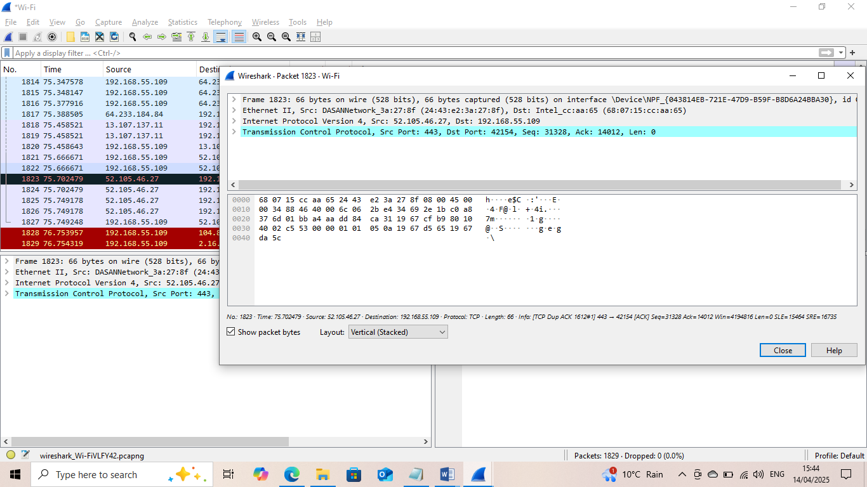
Let's break down the packet data:
From the captured packet above,the
- Transmission Control Protocol (TCP)*: This is the protocol used for communication between devices over the internet.
- Src Port: 443: The source port is 443, which is typically used for HTTPS (secure web traffic).
- Dst Port: 42154: The destination port is 42154, which is a randomly chosen port for this specific communication session.
- Seq: 31328: The sequence number is 31328, which is used to keep track of the order of packets in a conversation.
- Ack: 14012: The acknowledgment number is 14012, which indicates that the sender has received packets up to sequence number 14012 from the receiver.
- Len: 0: The length of the packet payload is 0, meaning this packet is likely an acknowledgment or a control packet without any data.
In simple terms, this packet is part of a secure web communication (HTTPS) and is likely an acknowledgment packet, confirming receipt of previous packets.

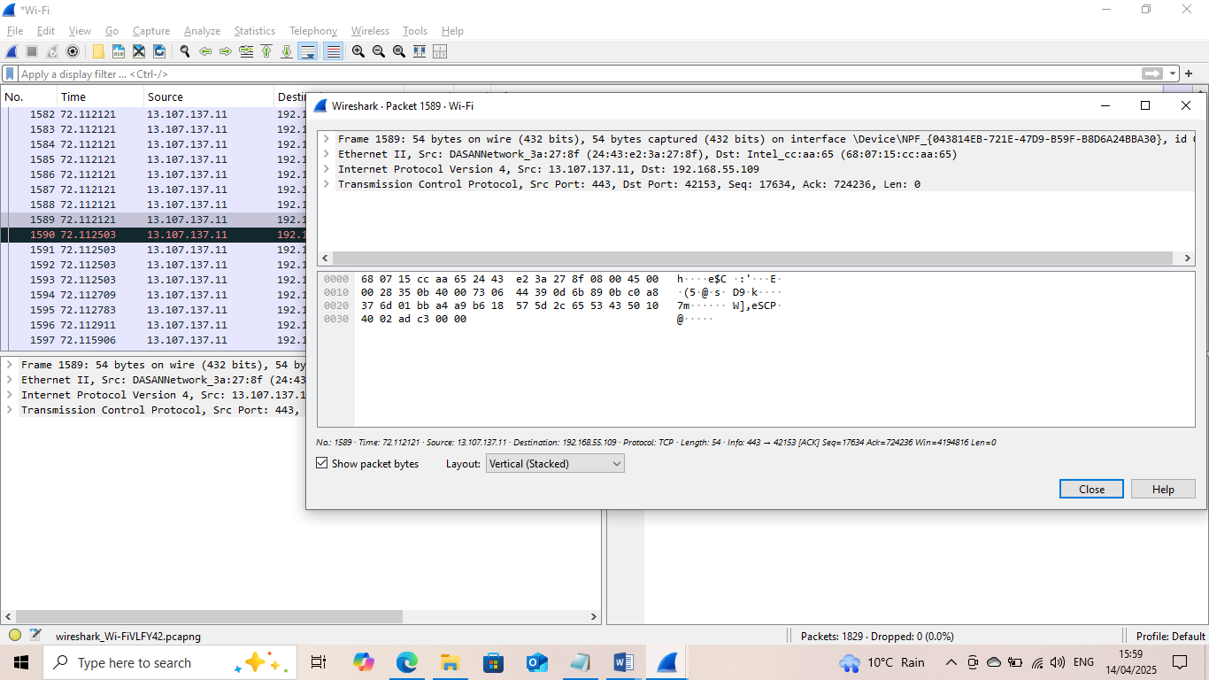
Frame 1590: 66 bytes on wire (528 bits), 66 bytes captured (528 bits) on interface \Device\NPF_{043814EB-721E-47D9-B59F-B8D6A24BBA30}, id < Ethernet II, Src: DASANNetwork_3a:27:8f (24:43:e2:3a:27:8f), Dst: Intel_cc:aa:65 (68:07:15: cc: aa:65)
Internet Protocol Version 4, Sc: 13.107.137.11, Dst: 192.168.55.109
Transmission Control Protocol, Src Port: 443, Dst Port: 42153, Seq: 17634, Ack: 724236, Len: 0
How best can you explain this above captured from Wireshark
Let's break down the captured packet:
Frame Information
- Frame 1590: This is the 1590th packet captured by Wireshark.
- 66 bytes on wire (528 bits), 66 bytes captured (528 bits): The packet is 66 bytes long, and Wireshark captured the entire packet.
Interface Information
- Interface \Device\NPF_{043814EB-721E-47D9-B59F-B8D6A24BBA30}: This is the network interface card (NIC) that captured the packet.
Ethernet Frame
Src: DASANNetwork_3a:27:8f (24:43:e2:3a:27:8f): The source MAC address is 24:43:e2:3a:27:8f, which belongs to a device from DASAN Network.
- Dst: Intel_cc:aa:65 (68:07:15:cc:aa:65): The destination MAC address is 68:07:15:cc:aa:65, which belongs to an Intel device.
Internet Protocol Version 4 (IPv4)
- Src: 13.107.137.11: The source IP address is 13.107.137.11, which is a public IP address.
- Dst: 192.168.55.109: The destination IP address is 192.168.55.109, which is a private IP address on a local network.
Transmission Control Protocol (TCP)
- Src Port: 443: The source port is 443, which is typically used for HTTPS (secure web traffic).
- Dst Port: 42153: The destination port is 42153, which is a randomly chosen port for this specific communication session.
- Seq: 17634: The sequence number is 17634, which is used to keep track of the order of packets in a conversation.
- Ack: 724236: The acknowledgment number is 724236, which indicates that the sender has received packets up to sequence number 724236 from the receiver.
- Len: 0: The length of the packet payload is 0, meaning this packet is likely an acknowledgment or a control packet without any data.
In summary, this packet is part of a secure web communication (HTTPS) between a server with IP address 13.107.137.11 and a client with IP address 192.168.55.109. The packet is an acknowledgment packet, confirming receipt of previous packets.
Additional screenshots from the live capture will include
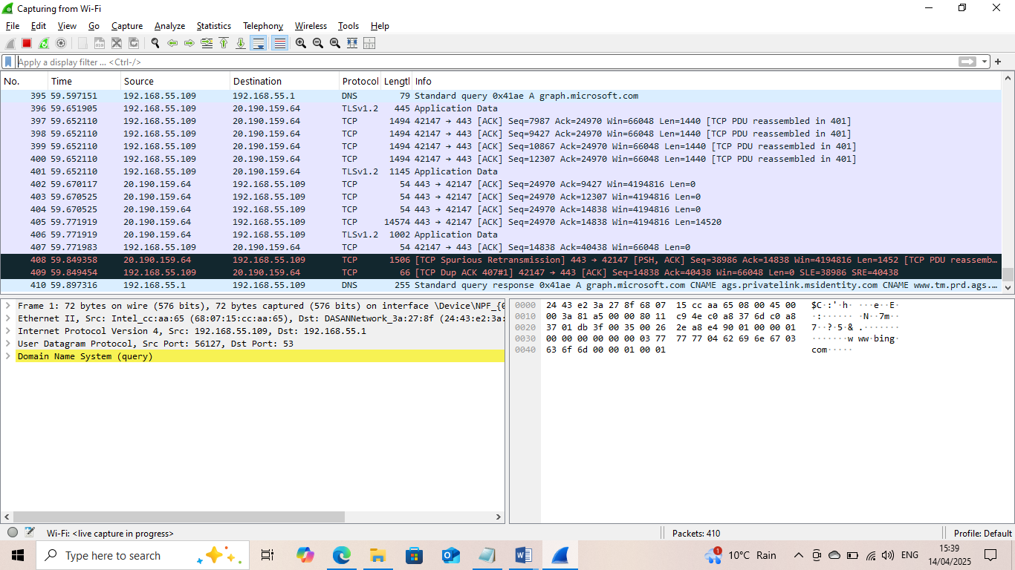
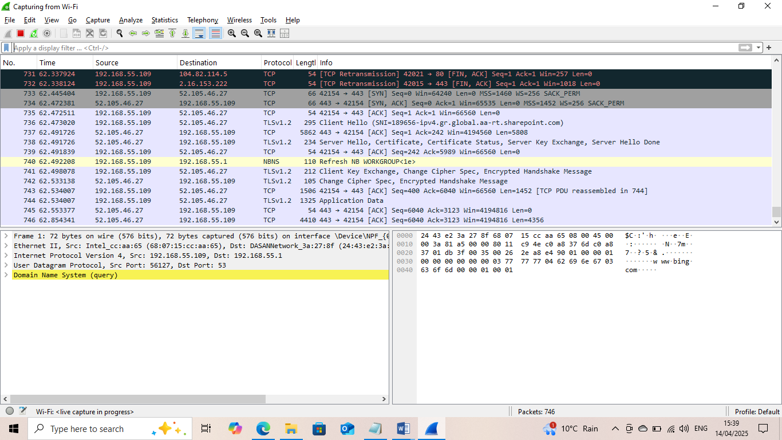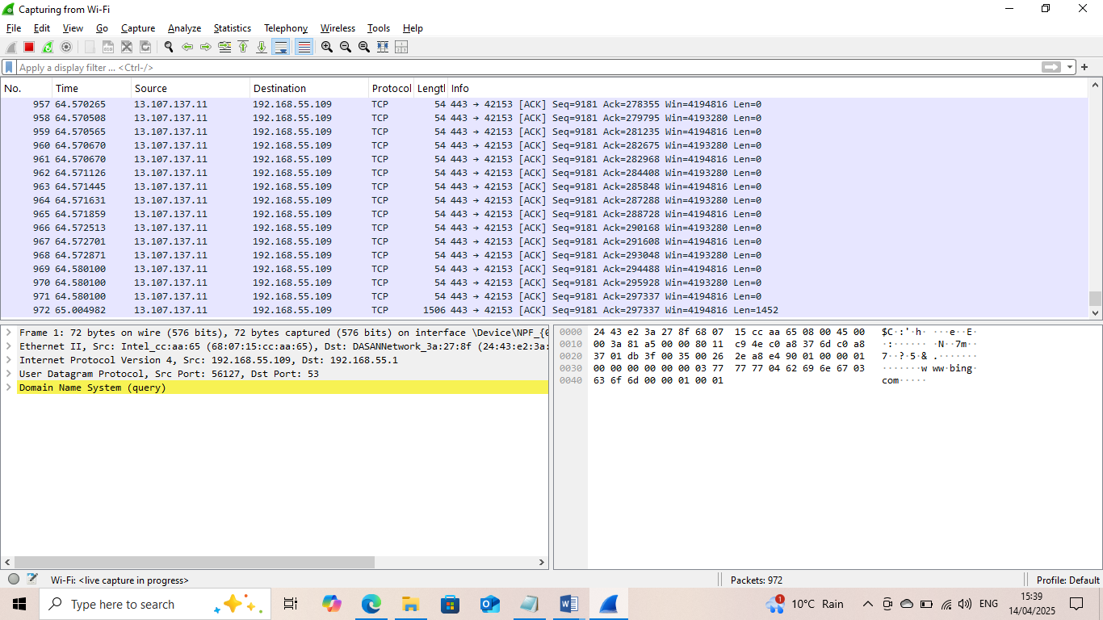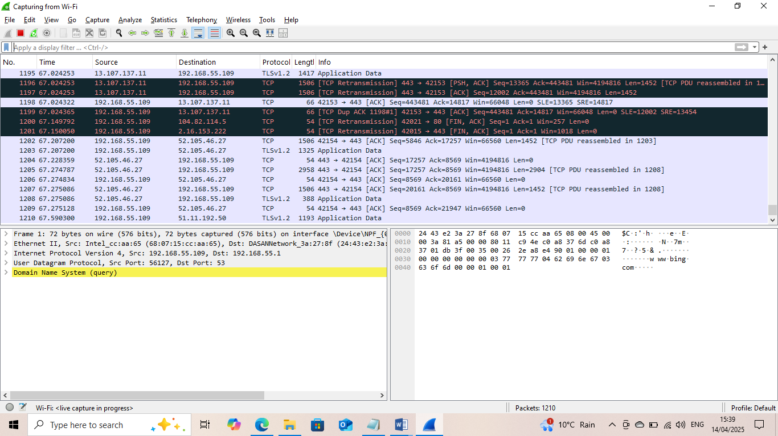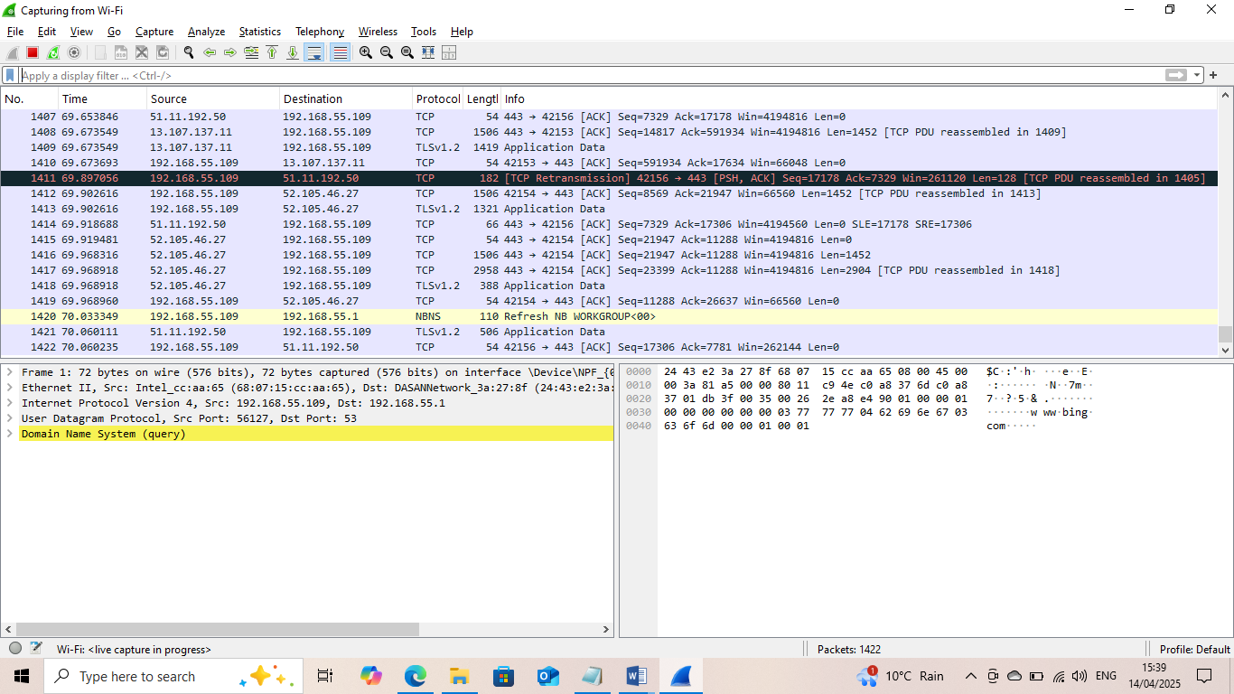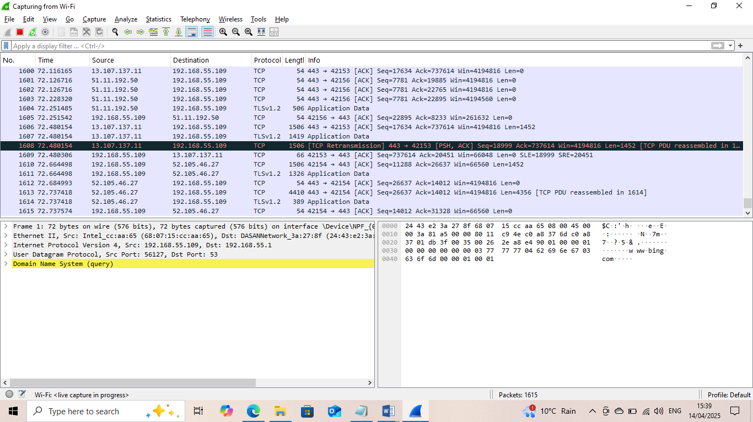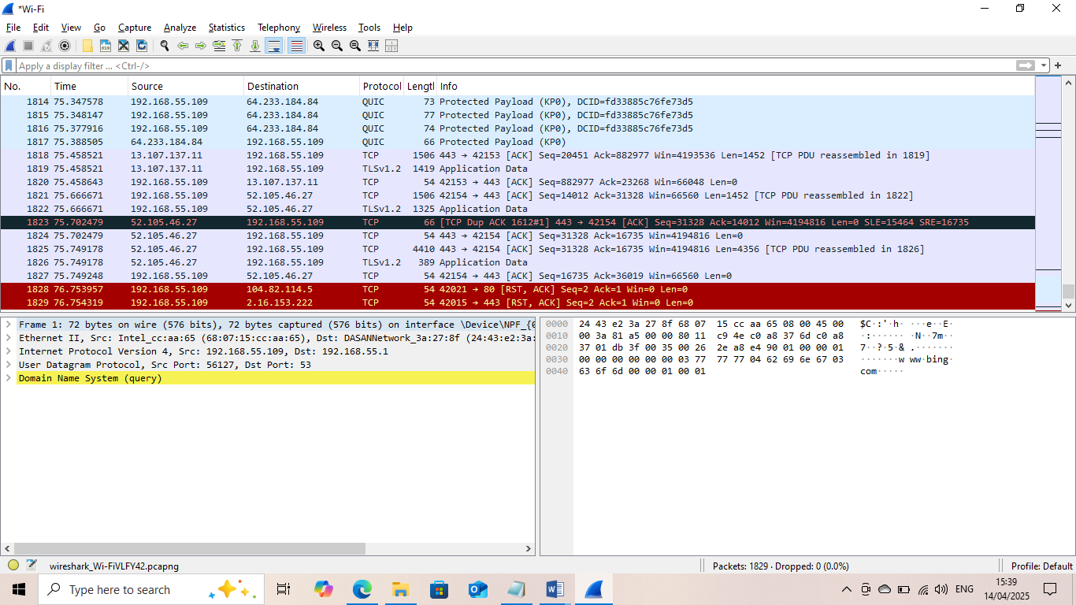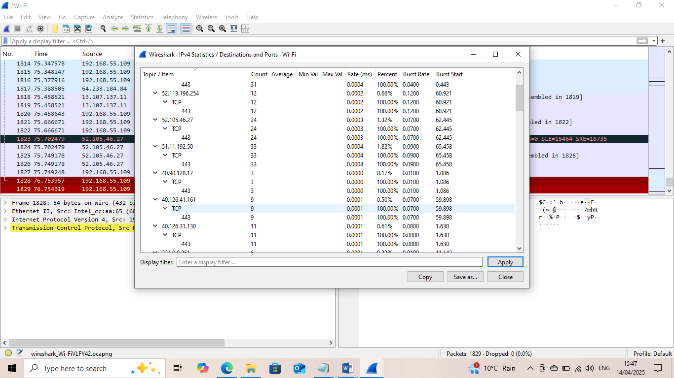
Also ,kindly find screenshots of Lab assignments on TryHackMe platform and HTB platform.


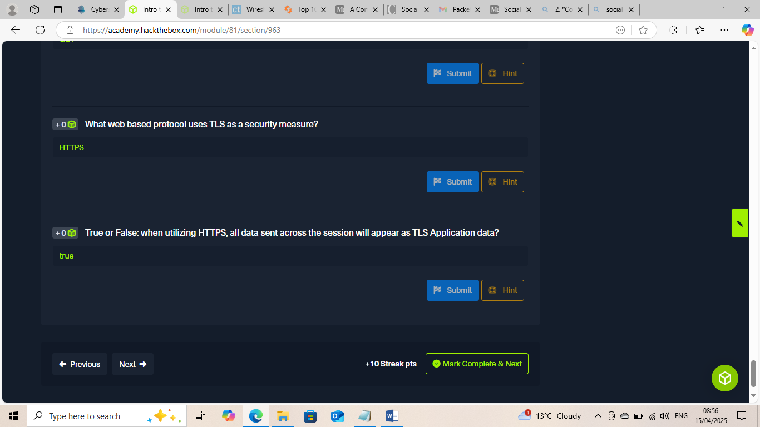

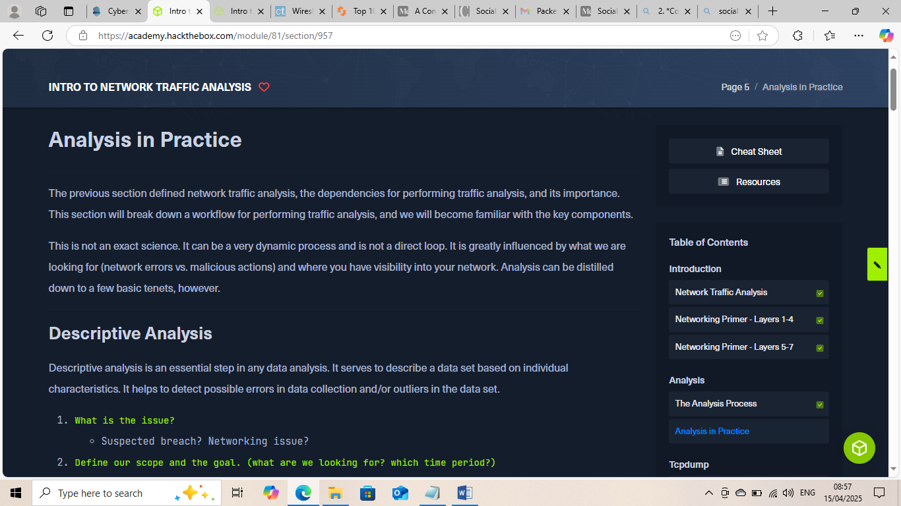

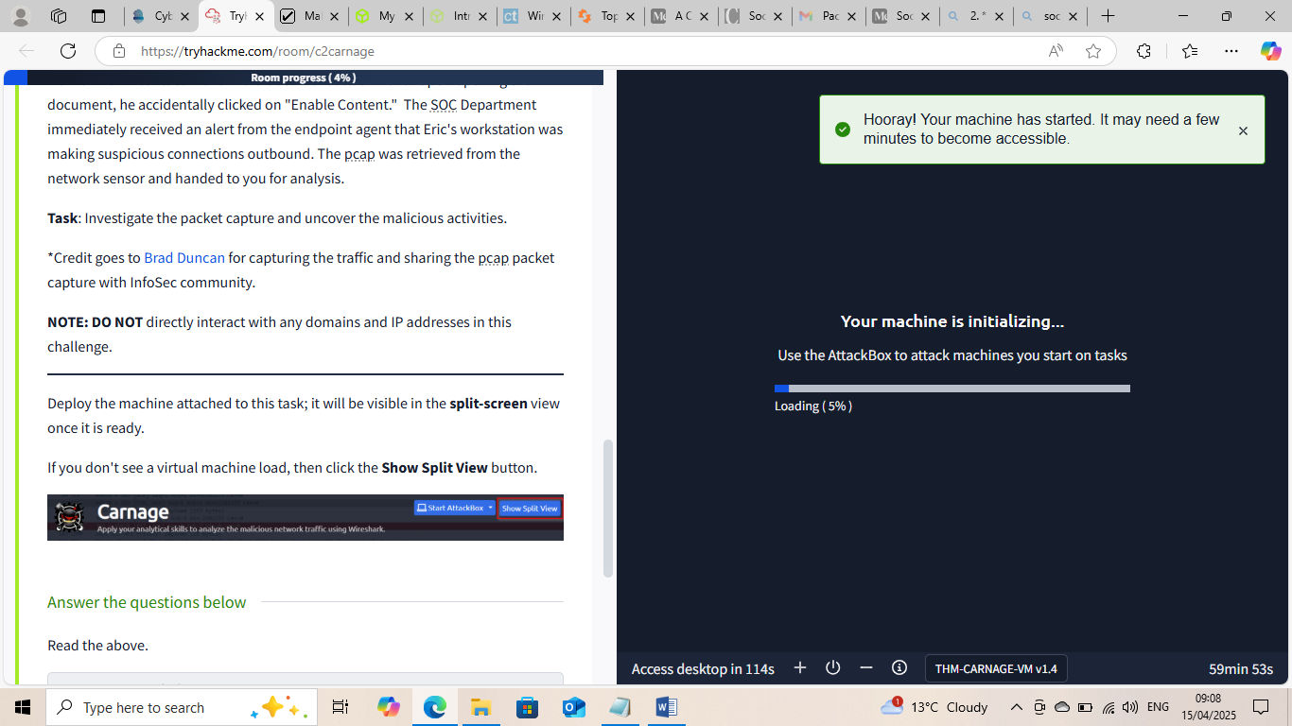
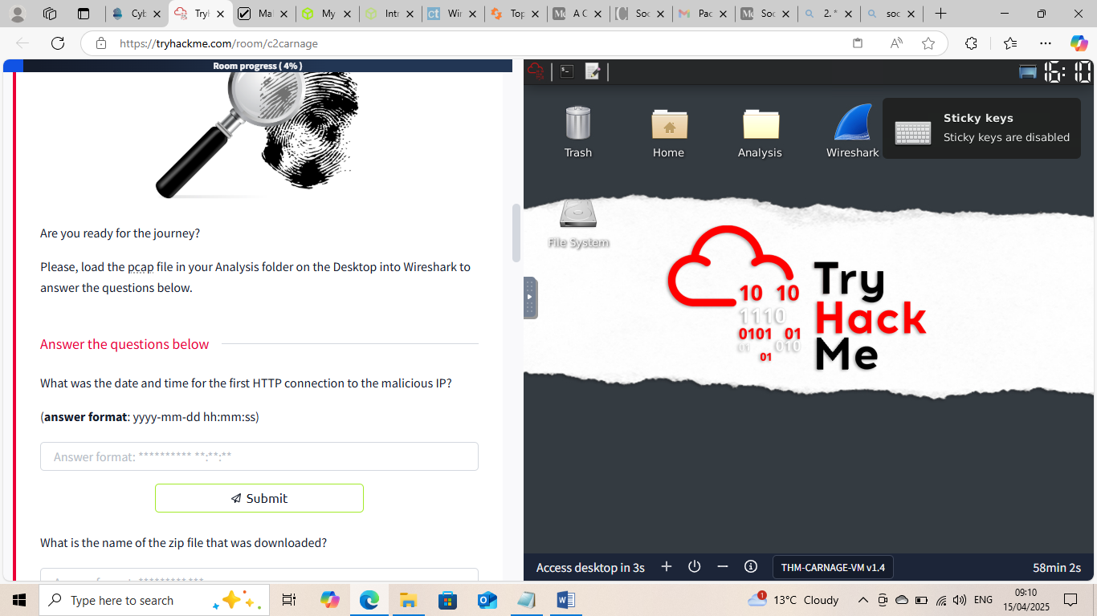

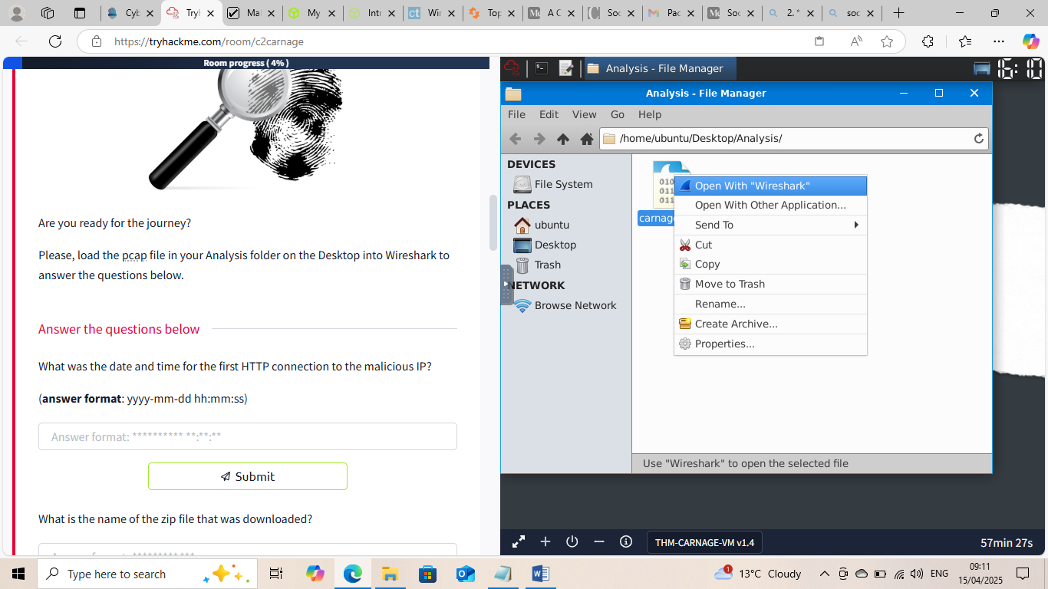
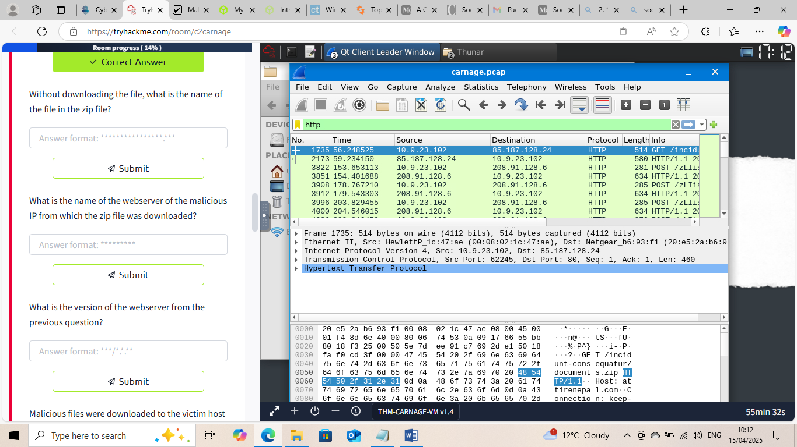

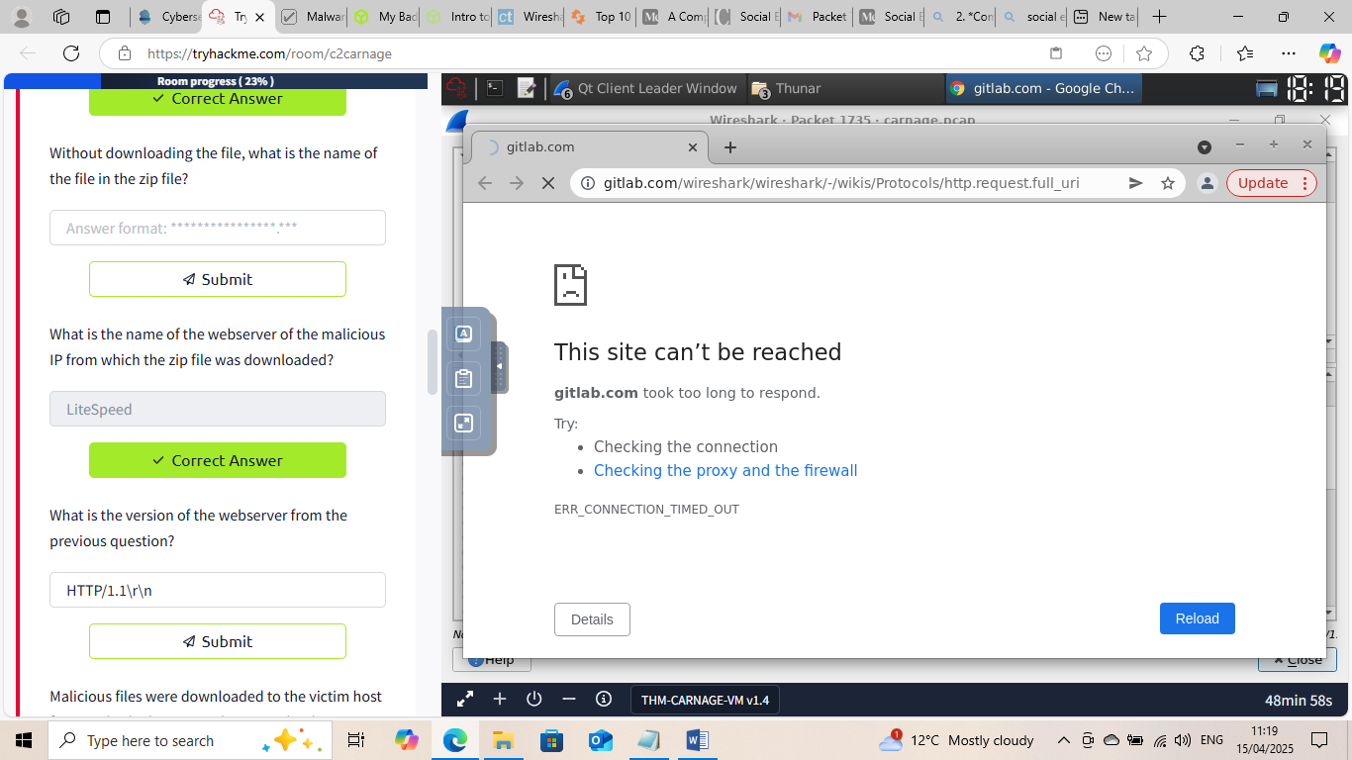
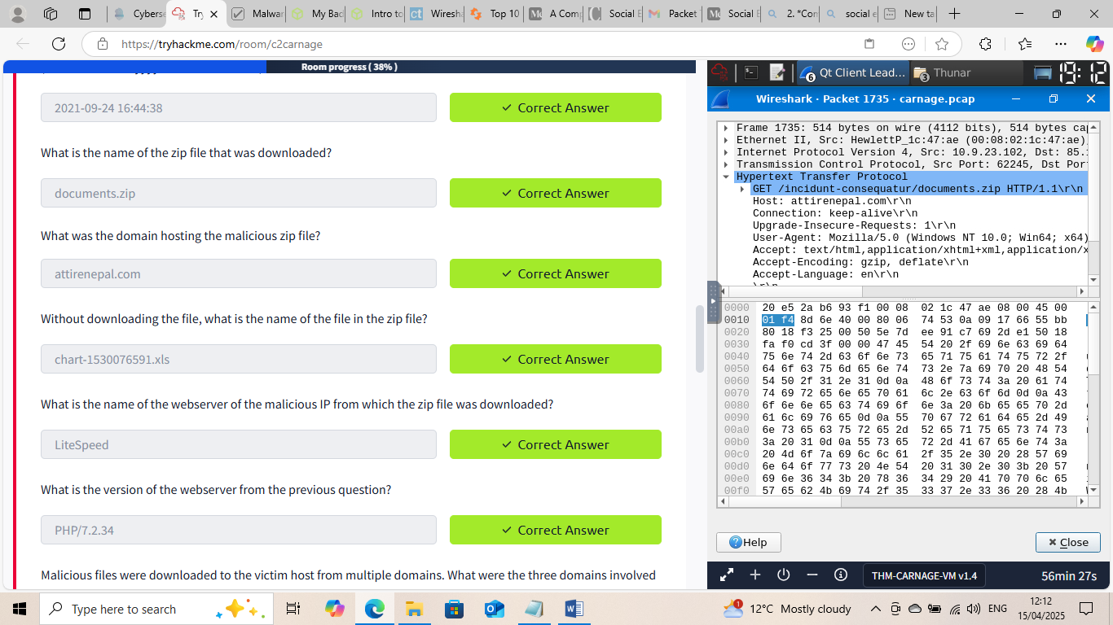

This Internship Task report was developed on [April, 15, 2025]

By:
[ samfelix15@gmail.com ]

